|  |
| --- |
| **For Internal Use** |
|  |

**SDGs Design International Awards 2025 Application Form  
 　　　　　　　　　　(For your Prefered Language if any)**

|  |  |  |
| --- | --- | --- |
| **Applicant’s Particulars (Individual or Group Entry) *Arial Font Size 9*** | | |
| **Given Name**  *(for Group Entry, representative name only)* | **Surname** | **Group Member Name(s)**  *(if any)* |
|  |  |  |
| **Name of Educational Institution** | **Faculty/Division**  *(if any)* | **Email**  *(for Group Entry, representative email address only)* |
|  |  |  |
| **Contact Number**  *(Please indicate the country code and area code)* | **Home Address** | |
|  |  | |
| **Theme: Living Together in an Era of Conflict “Societal Design Transcending Boundaries”** | | |
| Select the theme of your choice and place a "✓" in the box provided.  □1. Design for Peace □2. Designing with Marginalized Voices Theme □3. Living between Virtual and Real Worlds | | |
| **Title *(Arial Font Size 9)*** | | |
|  | | |
| **Summary (Aim, Target User, Appealing Points or Innovation) *(Arial Font Size 9, Max 300 words)*** | | |
|  | | |
| **Background Evidence *(Arial Font Size 9, Max 150 words)*** | | |
|  | | |
| **Anticipated Results and Social Impact *(Arial Font Size 9, Max 150 words)*** | | |
|  | | |

**IMPORTANT**

Please read the following rules carefully and adhere to the theme:

⋅Enter your entry content only in the space provided on the left-hand side.

⋅Do not write anything on this side of the page.

⋅Use the stated font type and font size.

⋅The application cannot exceed two A3 pages.

⋅Do not write more than the allowed number of words for each section.

⋅Applicants who do not adhere to the rules can be DISQUALIFIED.

Submit your application: **dsusdgscenter@gmail.com**

**중요**

다음 내용을 주의 깊게 읽고 규칙을 준수하시기 바랍니다.

⋅ 왼쪽에 제공된 공간에만 응모 내용을 입력하세요. 페이지의 오른쪽에는 아무것도 쓰지 마세요.

⋅ 지정된 글꼴과 글꼴 크기를 사용하세요.

⋅ 지원 양식은 A3 페이지 2장을 초과할 수 없습니다.

⋅ 각 섹션에 허용된 단어 수를 초과하여 작성하지 마십시오.

⋅ 규칙을 지키지 않는 지원자는 실격 처리될 수 있습니다.

**작품접수: dsusdgscenter@gmail.com**

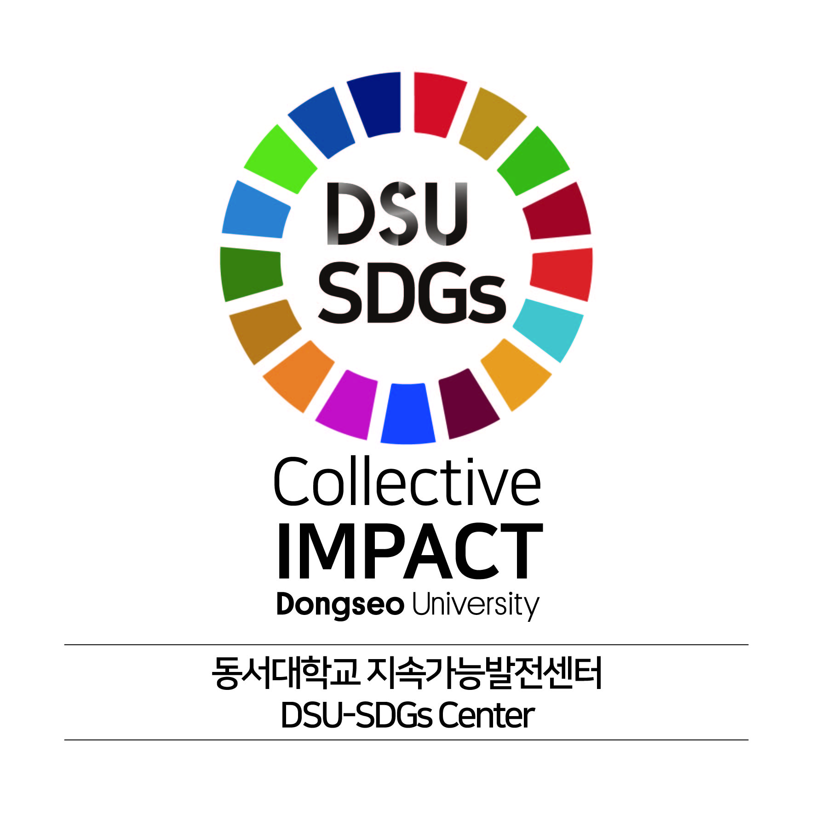

If you are not confident about writing the form in English, we recommend using free translation apps. (영어로 참가신청서를 작성하는 데 자신이 없다면 무료 번역 앱을 사용하는 것을 추천합니다).

**Design (Express your idea as text, figures, illustrastions, or images)**